1. References
W3Schools (n.d.) Java Exceptions. Available at: https://www.w3schools.com/java/java_try_catch.asp
W3Schools (n.d.) Java Try-with-Resources. Available at: https://www.w3schools.com/java/java_try_catch_resources.asp
W3Schools (n.d.) Java Write to Files. Available at: https://www.w3schools.com/java/java_files_write.asp
W3Schools (n.d.) Java Classes and Objects. Available at: https://www.w3schools.com/java/java_classes.asp
W3Schools (n.d.) Java ArrayList. Available at: https://www.w3schools.com/java/java_arraylist.asp
Oracle (n.d.) FileWriter Available at: https://docs.oracle.com/en/java/javase/26/docs/api/java.base/java/io/FileWriter.html

2. Acknowledgement of AI Use
Artificial Intelligence (AI), specifically ChatGPT, was used as a learning and development aid during the creation of the Banking System project. AI assistance was used to help combine and organize the Java code in BankingSystemMain.java and to explain the concept and implementation of exception handling using try, catch, and throw.
AI was also used to clarify programming concepts and to improve understanding of how the different Java classes work together, including the implementation of the TransactionLogger class. This included understanding how transaction records are written to a text file, how append mode works, and how file-writing errors are handled.
W3Schools and Oracle documentation were consulted as additional learning resources for Java exception handling, classes and objects, ArrayList, file writing, and the FileWriter class.
The project was reviewed and tested to help ensure that the banking system functions according to the assignment requirements. The use of AI is acknowledged in the interest of academic honesty and transparency.
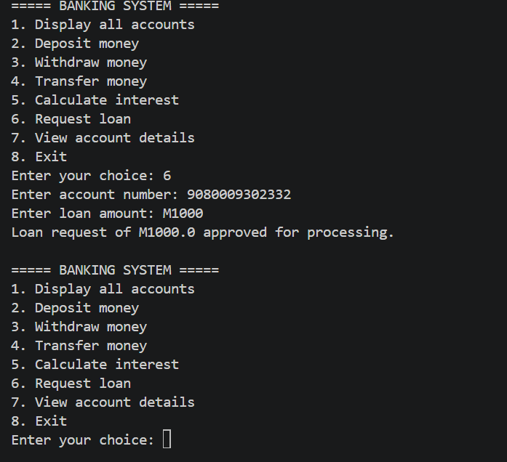
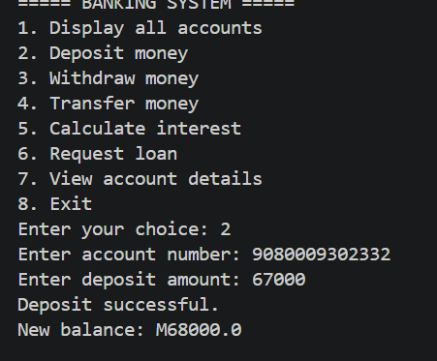

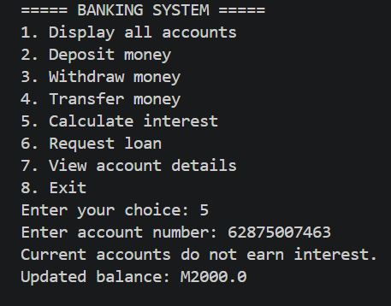

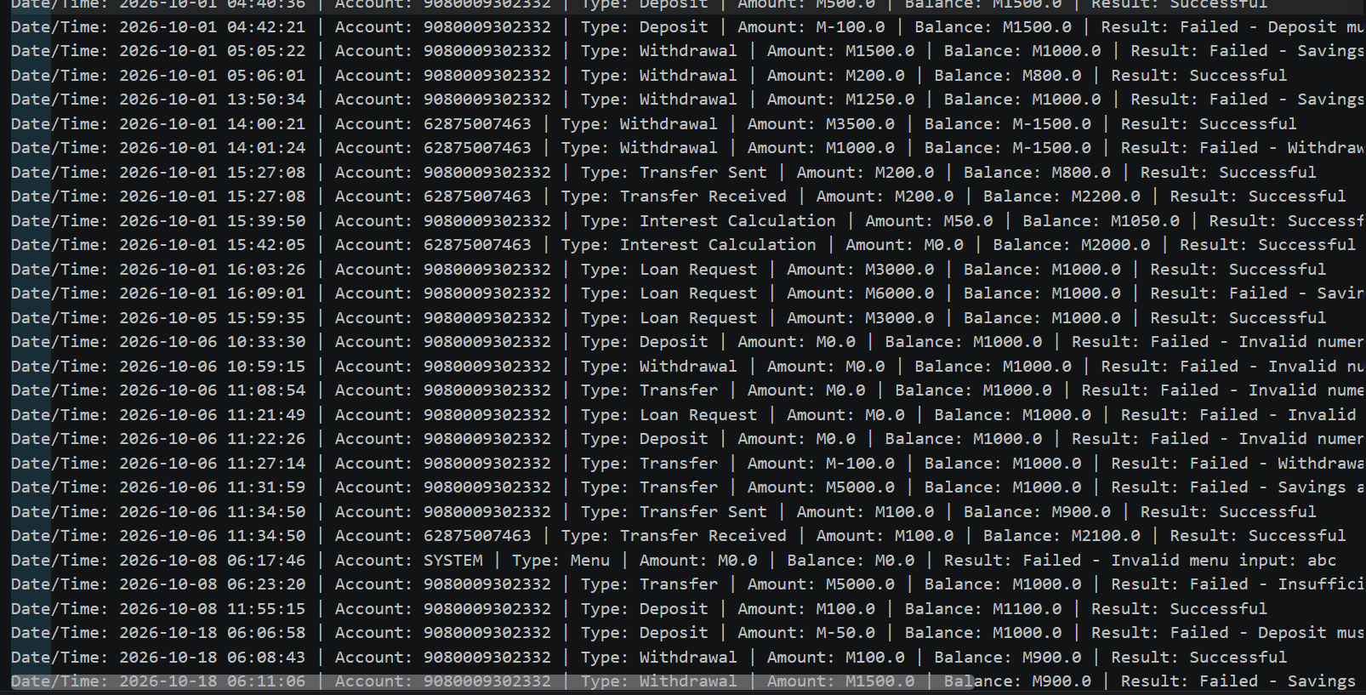

GROUP MEMBERS
Tlotliso Nkhets’e 901021260
Liteboho Machachamise 901020420
Sello Qoakeli 901020403

